GRAPHING MOTION

Displacement - time

• Constant Velocity
Δx
s (m)
t (s)
Δy
The slope or gradient of the line is given
by:
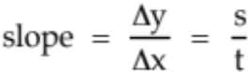

Hence the slope of the graph gives the
constant velocity of the body or object.

Examples

1. A cyclist moving at a constant velocity of 5.00 ms⁻¹ would generate the following
displacement - time graph. It would have a constant gradient as shown below.
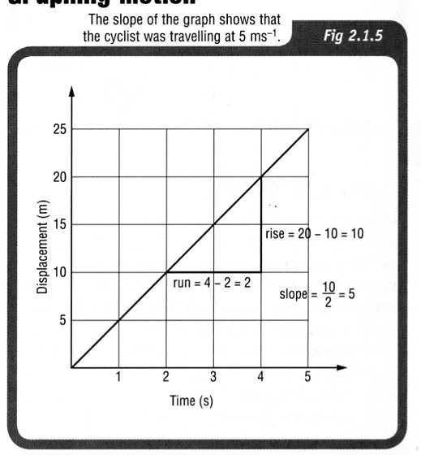

In maths you have probably
learnt that:

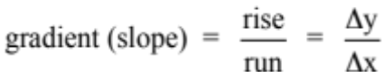

For this graph:

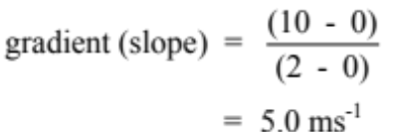

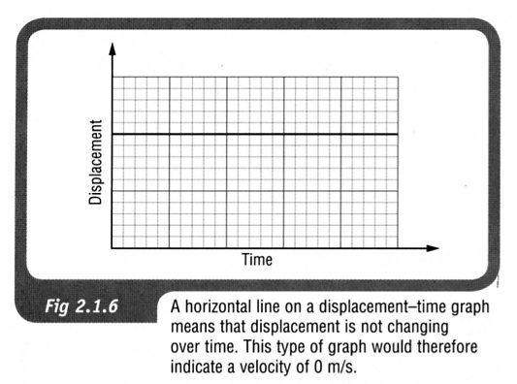
2. A displacement–time graph like that
shown indicates a vehicle that is
stationary (not moving). This is
because the rise is zero, so
the slope is zero.

Therefore the velocity is zero.

The greater the slope of displacement time graph therefore, the greater the velocity, as shown
in the graph below.

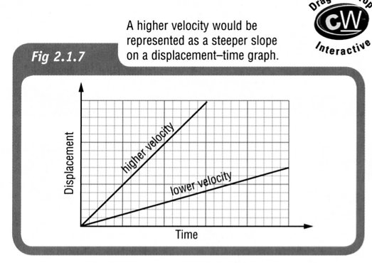

• Constant Acceleration

The graph at left represents an object
Δy
Δx
s (m)
t (s)
falling under gravity or one that is
uniformly accelerated across the ground.

The slope at a point on the curve gives the
instantaneous velocity of the object
at that time.

The graph is a parabola and clearly
suggests that s  t².

i.e. s = ut + ¹/₂ at²

Velocity - time

• Constant Velocity
v (ms⁻¹)
t (s)
The area under a v - t graph represents the displacement for the body.

i.e. s = v x t

• Constant Acceleration
The slope gives the acceleration of the body.
Δx
v (ms⁻¹)
t (s)
Δy

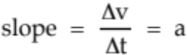

Area under graph = displacement
= 1/2 x base x height

Example

A car accelerates uniformly from a stop sign and reaches 15.0 ms⁻¹ after 10.0 s. It maintains this velocity for 15.0 s before decelerating uniformly to a stop in 5.00 s at a set of traffic lights. The entire motion occurs in a straight line.

(a) Draw a velocity - time graph for the motion.
(b) Calculate the displacement of the car in this time.

Acceleration - Time

• Constant Acceleration
a (ms⁻²)
t (s)
Area under graph = change in velocity
= Δv

Example

Draw the acceleration - time graph for the car motion in the previous example.

